**3. Background Literature Review**

**3.1. Atmospheric Science**

The Sun radiates light to the earth surface through the atmosphere, and is essential to understand atmospheric science. The earth’s atmosphere can be divided into 4 layers, which are troposphere, stratosphere, mesosphere and ionosphere. This research focuses on troposphere, where the aerosols and water vapour are distributed [1]. Figure 1 shows that the troposphere is from the ground to 14km from the earth surface. It contains different climates and weathers such as rain and wind currents.

Aerosols are particles which scatter or absorb optical wavelengths in air. They change their states within the troposphere through chemical reactions with water vapour, oxygen and nitrogen, they also migrate with the wind current in the atmosphere.

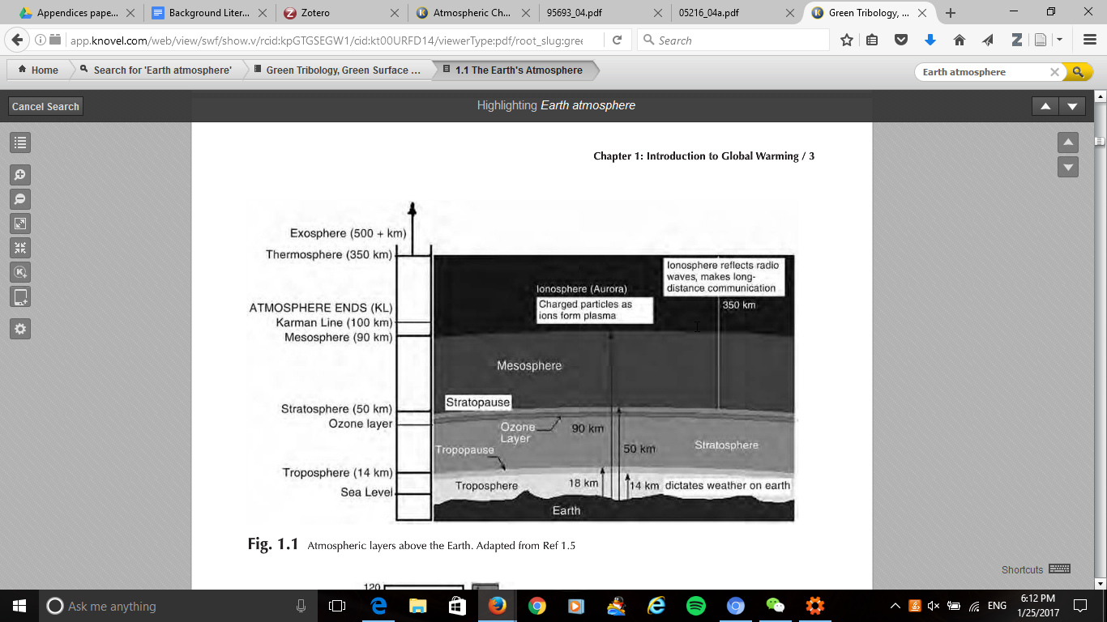

Figure 1 - Atmospheric Layer Diagram [1]

The aerosols can arise naturally from natural events and disasters such as volcanic ash, dust from sandstorm and convection reaction of water driven by solar radiation. They can also come artificially from man-made events such as polluted gases from combustion process [3] [4]. Section 3.2 gives more detail of the properties of aerosols.

**3.2. Aerosols Properties**

This section focuses on the aerosol. Aerosols are particles which scatter or absorb optical wavelengths in air. They come from natural and man-made sources such as volcanic activities, Sahara dust storms, and fossil fuel combustion. There are various sizes and shapes of aerosols spreading from a range of nanometre to micrometre. [2]. Figure 2 shows that various physical and chemical conversion activities form different sizes of aerosols and they change both physical and chemical properties of the aerosols. For example, the physical mechanisms on the aerosols such as condensation and coagulation change the aerosols to accumulation mode. They can be removed by rain-wash or sedimentation depending on their sizes. [3].[4]

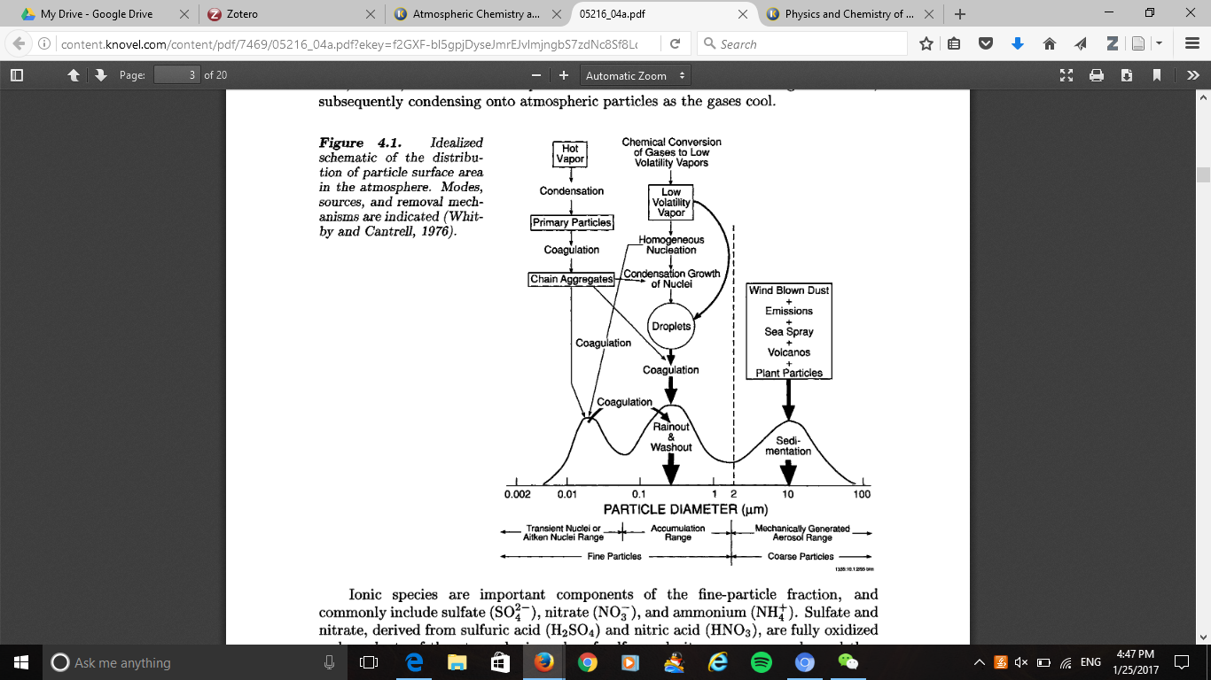

Figure 2 - Idealised schematic of the sources and sink of primary and secondary aerosols. [5]

Aerosols have impact on changing the climate by absorbing or scattering optical wavelengths within the absorption spectrum. Sulfate, dust, black carbon and nitrate are major aerosols scattering in the atmosphere.  We will now examine them each in turns in the next few sections.

**3.2.1. Sulfate**

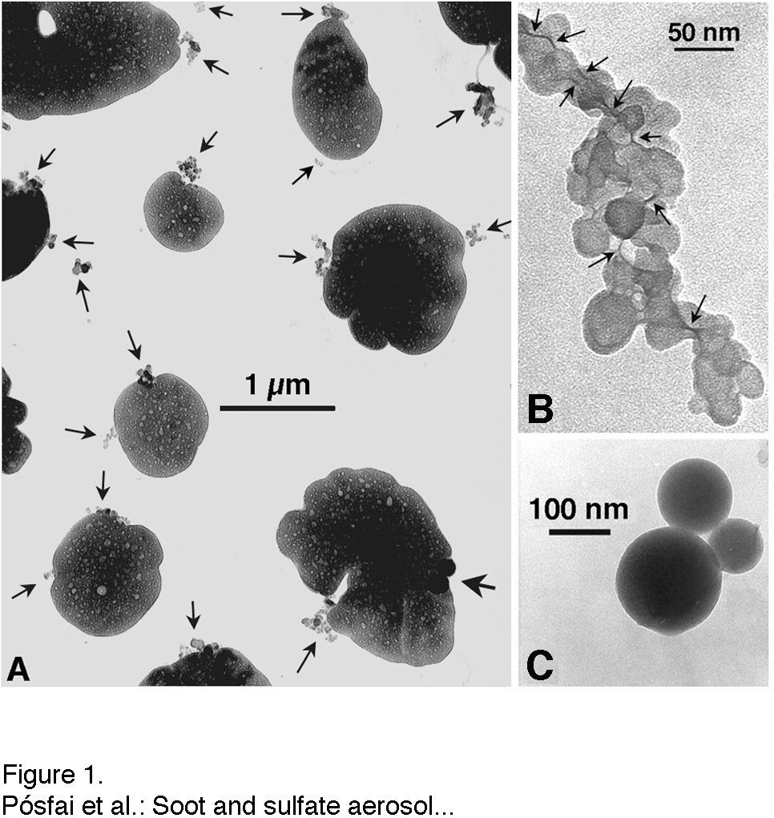

Figure 3 - Soot and Sulfate aerosol sizes (A) 1000nm (B) 50nm (C) 100nm [6]

Volcanic activities and man-made pollution such as fossil fuel combustion release sulfur dioxide into the atmosphere. Sulfur dioxide is a harmful aerosol to human and climate. It forms sulfuric gases through convection with warm air for sulfate aerosols in Figure 4. Figure 3 shows that the sizes of sulfate aerosols are varied from 50nm to 1000nm. The aerosols in are fine particles that can be easily inhaled into the lungs, which causes lung cancer. They also have cooling effect to the climate with their scattering properties. [3] It can scatter and absorb wavelengths in the atmosphere ranged from 370nm to 880nm.[7]

Sulfate aerosols suspend in both the troposphere and stratosphere [3] They are reactive to water vapour and other gases such as nitrogen and chlorine. A chemical reaction that includes sulfate aerosols in the stratosphere is heterogeneous chemical reaction.

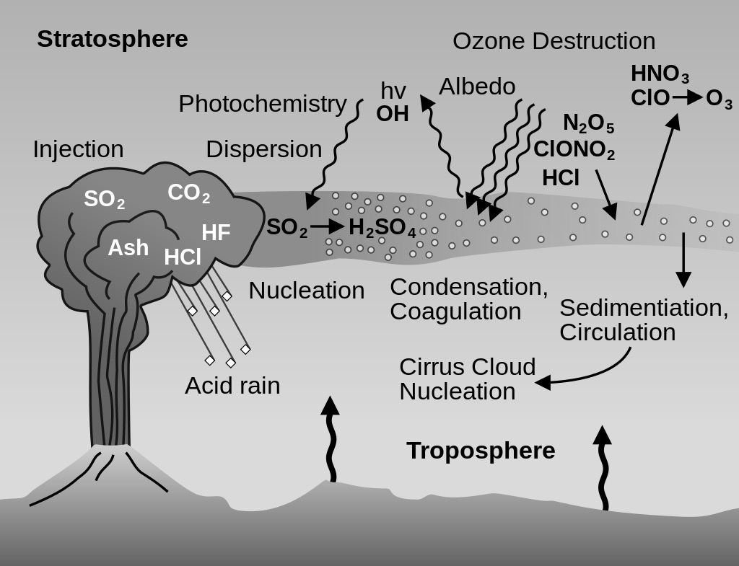

Figure 4 – Sulfate aerosol cycle from volcanic ash [8]

This reaction is between nitrogen and chlorine gases, and it occurs on the surface of sulfate aerosols in the stratosphere. This will cause destruction to the ozone layer in the stratosphere. Sulfate aerosol can react with gases such as hydrochloric acid to form ozone layer, which causes ozone destruction. The level of chemical reaction is depending on the size of sulfate aerosol.

**3.2.2. Dust**

Natural events or man-made events can form dust, which is an aerosol harmful to human and climate. Dust mainly comes from deserts like Sahara desert but it can also come from man -made disasters or building demolitions.[7] They can scatter and absorb wavelengths within the visible range. The concentration of dust can affect our visibility, and causing respiratory diseases such as asthma[2]. Coarse dust particles and fine dust particles are two categories of dust particles, and they are depending on its sizes. Coarse dust particles have sizes from 2.5µm to 10µm, and fine dust particles have sizes with less than 2.5µm. [9].

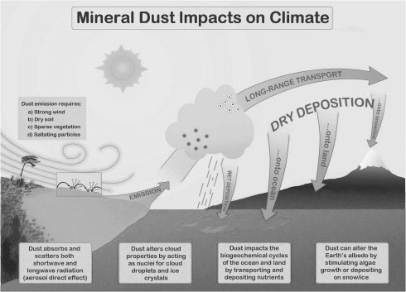

Figure 5 – Interactions between dust and the atmosphere [10]

They also can cause modifications on other atmospheric gases and pollutants such as nitrogen dioxide, hydrogen, and ozone. Water vapour molecules, and hydrogen ions attach at the peripheral round of the dust particle surface. Heterogeneous reaction is the name of the modification process. [9] Figure 5 shows that the dust can travel with wind current and react with water vapour to form aerosols.

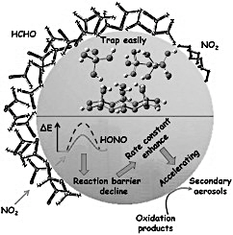

Figure 6 – Heterogeneous chemical reaction of dust with nitrogen dioxide [10]

Figure 6 shows that dust can react with nitrogen dioxide, and the reactive product undergoes photochemical reactions to change the physicochemical properties of the dust particle. Dust can also spread from the source region to remote locations through wind currents. [11]. The intensity of the heterogeneous chemical reaction between nitrogen oxide and dust is depending on the sizes of dust particles. This means that more nitrogen oxide will react on the surface of the dust particles when the size increases.[12].

[1] R. Chattopadhyay, *Green Tribology, Green Surface Engineering, and Global Warming*. ASM International, 2014.

[2] J. G. Titus and K. E. Anderson, *Coastal sensitivity to sea-level rise: a focus on the mid-Atlantic region*, vol. 4. Government Printing Office, 2009.

[3] Guy P., John J., and Geoffrey S., ‘Aerosols and Clouds’, in *Atmosperic Chemistry and Global Change*, 117-136: Oxford University Press, 2014.

[4] Jedol Dayou, Jackson Hian Wui Chang, and Justin Sentian, ‘Introduction’, in *Ground-Based Aerosol Optical Depth Measurement Using Sunphotometers*, Springer.

[5] K. . Whitby, R. . Husar, and B. Y. . Liu, ‘The aerosol size distribution of Los Angeles smog’, *J. Colloid Interface Sci.*, vol. 39, no. 1, pp. 177–204, Apr. 1972.

[6] B. Allen, ‘Atmospheric Aerosols: What Are They, and Why Are They So Important?’, *NASA*, 06-Apr-2015. [Online]. Available: http://www.nasa.gov/centers/langley/news/factsheets/Aerosols.html. [Accessed: 18-Jul-2016].

[7] S. Lim, M. Lee, S.-W. Kim, S.-C. Yoon, G. Lee, and Y. J. Lee, ‘Absorption and scattering properties of organic carbon versus sulfate dominant aerosols at Gosan climate observatory in Northeast Asia’, *Atmospheric Chem. Phys.*, vol. 14, no. 15, pp. 7781–7793, Aug. 2014.

[8] Kenneth A. McGee, Michael P. Doukas, Richard Kessler, and Terrence M. Gerlach, ‘Impact of Volcanic Gases’. [Online]. Available: https://pubs.usgs.gov/of/1997/of97-262/of97-262.html. [Accessed: 18-Jan-2017].

[9] Y. Ji, H. Wang, G. Li, and T. An, ‘Theoretical investigation on the role of mineral dust aerosol in atmospheric reaction: A case of the heterogeneous reaction of formaldehyde with NO2 onto SiO2 dust surface’, *Atmos. Environ.*, vol. 103, pp. 207–214, Feb. 2015.

[10] N. Mahowald *et al.*, ‘The size distribution of desert dust aerosols and its impact on the Earth system’, *Aeolian Res.*, vol. 15, pp. 53–71, Dec. 2014.

[11] H. Chen, J. G. Navea, M. A. Young, and V. H. Grassian, ‘Heterogeneous Photochemistry of Trace Atmospheric Gases with Components of Mineral Dust Aerosol’, *J. Phys. Chem. A*, vol. 115, no. 4, pp. 490–499, Feb. 2011.

[12] L. Zhou, W. Wang, M. Ge, and S. Tong, ‘Heterogeneous uptake of gaseous hydrogen peroxide on mineral dust’, *J. Environ. Sci.*, vol. 40, pp. 44–50, Feb. 2016.